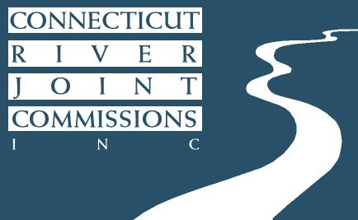
Connecticut River Joint Commissions
10 Water Street, Suite 225
Lebanon, NH 03766
(603) 727-9484
http://www.crjc.org

CRJC Headwaters Subcommittee Annual Report - 2018

The Headwaters Subcommittee of the Connecticut River Joint Commissions (CRJC) consists of two volunteers nominated by each of the following municipalities: Canaan, Lemington, Bloomfield, Brunswick, and Maidstone in Vermont; and Pittsburg, Clarksville, Stewartstown, Colebrook, Columbia, Stratford, and Northumberland in New Hampshire.

The Subcommittee provides a local voice to help steward the resources on or affecting a portion of the Connecticut River, particularly on topics related to the maintenance of good water quality and wildlife habitat. The Subcommittee is one of five that make up the Connecticut River Joint Commissions since 1989. Specific responsibilities include providing advice to NHDES, VTANR and municipalities on matters pertaining to the river; reviewing and commenting on proposed permits and plans; and maintaining a corridor management plan.

Subcommittee members held discussions and kept updated on a series of important issues relating to the watershed such as the “Wildlands and Woodlands: Broadening the Vision for New England” report; Aquatic Invasive Species; dam maintenance for Lake Francis, Second Connecticut Lake, and First Connecticut lake; and the ALPINE project. In addition, the topic of bringing on new members was discussed due to the lack of representation form a handful of towns. The Subcommittee reviewed and commented on a series of permits from across the region and on a range of issues such as wetland impacts, mitigation approaches and stormwater drainage. Members discussed bringing in speakers to support engagement and capacity. Finally, the members have distributed the CRJC Homeowner’s Guide for Water Quality Protection and the CRJC Shoreline Buffer Fact Sheet to central town locations (e.g. Public Library or Town Office).

There are currently openings on the Subcommittee in several communities. There is one representative in Pittsburg, Stewartstown, Colebrook, Northumberland, Canaan, Bloomfield and Maidstone. There is no representation from Clarksville, Lemington and Brunswick. If you or someone in your community is interested in working with volunteers from area communities on river conservation issues and serving as a liaison to the Headwaters Subcommittee, please contact our staff support Olivia Uyizeye at ouyizeye@uvlsrpc.org to learn more.

